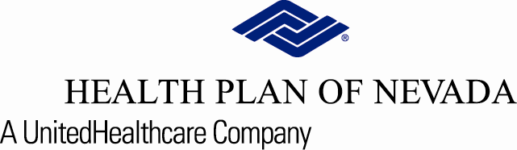

Physicians, Practice Managers and Staff: YOU’RE INVITED!

Health Plan of Nevada Medicaid and Nevada Check Up

**Wednesday, July 27, 2022 from 11 a.m. to noon**

Please join us for an informational webinar about Health Plan of Nevada’s Medicaid plan and Nevada Check Up.

Meeting Topics:

* Cultural Competency
* Hospice and Palliative Care
* Health Education and Wellness programs
* Behavioral Health contacts
* …and more

Pre-registration is required in order to receive the invite. **Please secure your spot by filling out the form below and returning to us no later than Monday, July 25, 2022.** The webinar invite will be sent to the email address(es) provided one day prior to the meeting date.

Completed RSVP should be emailed to [PRI@uhc.com](mailto:PRI@uhc.com).

|  |  |
| --- | --- |
| Practice/Physician Name: | TAX ID#: |
| Attendee email: | Attendee email: |
| Attendee email: | Attendee email: |
| Attendee email: | Attendee email: |
| Attendee email: | Attendee email: |

**For More Information:**

If you have questions, please contact your Health Plan of Nevada Physician Advocate team at   
702-242-7088 or 1-800-745-7065, Option 2 then option 5.

Thank you,

The Health Plan of Nevada Team

Provider Relations